**Chapter 5 Material**

Fill in the missing steps in the following diagram.

Be able to describe the role of an agonist or antagonist in this diagram:

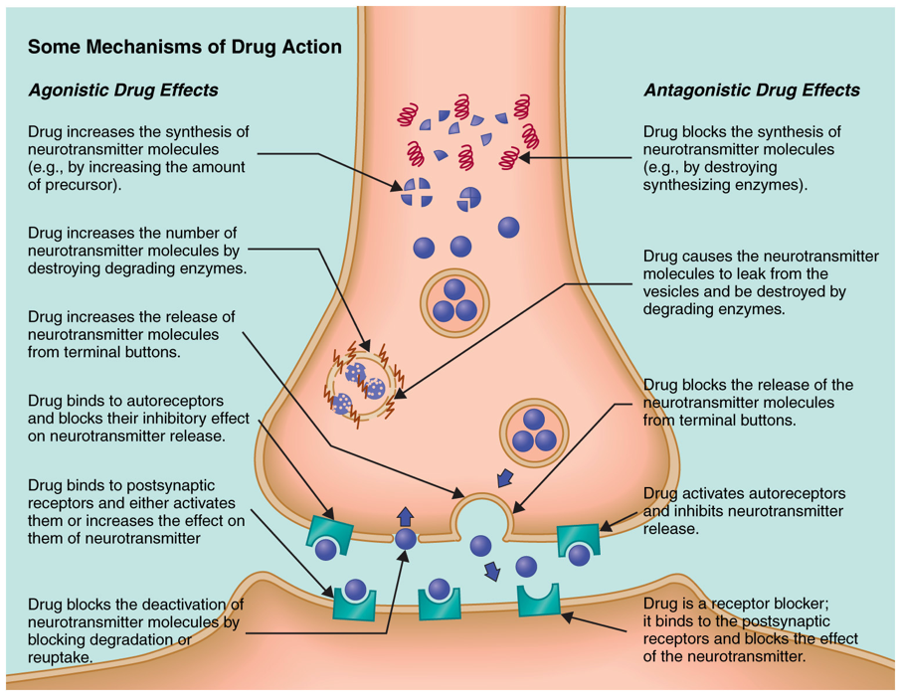

Fill in the blanks:

Describe the 3 major DA pathways:

Mesolimbic:

Mesocortical:

Nigrostriatal:

Describe the differences in the addiction theories below:

|  |  |
| --- | --- |
| Physical-dependence theory | Incentive-sensitization theory |
|  |  |

**Chapter 5 Practice Questions:**

Q: Which of the three pathways plays a major role in drug abuse, reward seeking, and risk taking?

A:

Q: True or false, exposure to 1 drug can produce tolerance to similar drugs?

A:

Q: Do amyloid plaques accumulate inside or outside of the cell?

A:

Q: Which form of tolerance describes the decreased responsiveness at the site of action?

A:

Q: True or false, if you have withdrawal symptoms you are addicted to a drug?

A:

Q: Amphetamines most important effect if inhibiting reuptake of Dopamine?

A:

Q: What are 3 causes of relapse?

A:

**Chapter 8 Material**

**Stress, emotion, health**

Complete the matching activity:

A: James-Lange

B: Cannon-Bard

C: Schachter-Singer

|  |  |
| --- | --- |
|  | Bodily reactions cause feelings |
|  | Brain causes feelings and reactions at the same time |
|  | Cognitive appraisal of context drives interpretation of feelings as one emotion or another |

**Brain Regions Important for Emotion, Focus on Aggression/Fear**

Describe the Limbic Areas implicated in emotion:

anterior cingulate-

hypothalamus-

septal nuclei-

amygdala-

insular cortex-

basal ganglia-

**Stress and Health Pathways**

Fill in the blanks to describe the 2 physiological stress pathways:

Be able to describe/contrast the 2 pathways through which stress influences immune health.

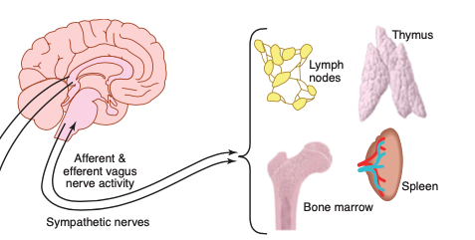

**Chapter 8 Practice Questions:**

Q: Which stress pathway is activated more rapidly?

A:

Q: How does stress influence the immune system?

A:

Q: True or false, the adrenal medulla produces cortisol?

A:

Q: Which immune cells are a part of the adaptive immune response?

A:

Q: Which immune cell can attack and destroy certain kinds of cancer cells?

A:

Q: Stress can:

1. Reduce immune system function
2. Impair health
3. Mobilize the immune system
4. A & B
5. A, B, & C

**Neurodegenerative Diseases**

|  |  |  |
| --- | --- | --- |
|  | **Parkinson’s** | **Alzheimer’s** |
| **Physiology** |  |  |
| **Symptoms** |  |  |